# Assignment No.1

**Question :**

1. Update customer table set city is new delhi where city is mumbai.

2. Describe structure of of table customer.

1. Delete from table customer where cit is new delhi.
2. Alter table customer add column zipcode varchar2(12)
3. Drop table costomer.

create table customer(

id varchar2(6) primary key, name varchar2(20),

phone varchar2(20), address varchar2(20), city varchar2(20), stat2 varchar2(10));

insert into customer values('001','dharmendra','9654084939','mohannagar','gzb','up') insert into customer values('002','ravi','945454545','rajendra nagar','delhi','delhi') insert into customer values('003','puneet','966565456','sheelam pur','delhi','delhi') insert into customer values('004','vinod kumar','9665456564','vijay nagar','gzb','up') insert into customer values('005','harsh','9667657657','muradnagar','gzb','up')

insert into customer values('006','vinit kumar','9654044354','puna','puna','maharasth') insert into customer values('007','sonia','9654084349','mohannagar','gzb','up')

insert into customer values('008','seema','9654084349','hempur','mumbai','up') select * from customer

|  |  |  |  |  |  |
| --- | --- | --- | --- | --- | --- |
| **id** | **name** | **phone** | **address** | **city** | **stat 2** |
| 001 | dharmendra | 9654084939 | mohannagar | gzb | up |
| 002 | ravi | 945454545 | rajendra nagar | delhi | delhi |
| 003 | puneet | 966565456 | sheelam pur | delhi | delhi |
| 004 | vinod kumar | 9665456564 | vijay nagar | gzb | up |
| 005 | harsh | 9667657657 | muradnagar | gzb | up |
| 006 | vinit kumar | 9654044354 | puna | puna | maharasth |
| 007 | sonia | 9654084349 | mohannagar | gzb | up |
|  |  |  |  |  |  |

1. update customer set city='delhi' where city='mumbai'

|  |  |  |  |  |  |  |  |  |  |  |  |
| --- | --- | --- | --- | --- | --- | --- | --- | --- | --- | --- | --- |
| **table** | **column** | **data type** | **length** | **precision** | **scale** | **primary** | **key** | **nullable** | **default** | **comment** | |
| customer | id | varchar2 | 6 | - | - | 1 | - | | - | - |  |
|  | name | varchar2 | 20 | - | - | - |  | | - | - |  |
|  | phone | varchar2 | 20 | - | - | - |  | | - | - |  |
|  | address | varchar2 | 20 | - | - | - |  | | - | - |  |
|  | city | varchar2 | 20 | - | - | - |  | | - | - |  |
|  | stat2 | varchar2 | 10 | - | - | - |  | | - | - |  |
|  | zipcode | varchar2 | 12 | - | - | - |  | | - | - |  |
|  | | | | | | | | | 1 - 7 | |  |

|  |  |  |  |  |  |  |  |  |  |  |  |
| --- | --- | --- | --- | --- | --- | --- | --- | --- | --- | --- | --- |
| **table** | **column** | **data type** | **length** | **precision** | **scale** | **primary** | **key** | **nullable** | **default** | **comment** | |
| customer | id | varchar2 | 6 | - | - | 1 | - | | - | - |  |
|  | name | varchar2 | 20 | - | - | - |  | | - | - |  |
|  | phone | varchar2 | 20 | - | - | - |  | | - | - |  |
|  | address | varchar2 | 20 | - | - | - |  | | - | - |  |
|  | city | varchar2 | 20 | - | - | - |  | | - | - |  |
|  | stat2 | varchar2 | 10 | - | - | - |  | | - | - |  |
| 4. alter table customer add zipcode varchar2(12) | | | | | | | | | 1 - 6 | |  |

1. desc customer

|  |  |
| --- | --- |
| **name** | **city** |
| dharmendra | gzb |
| ravi | delhi |
| puneet | delhi |
| vinod kumar | gzb |
| harsh | gzb |
| vinit kumar | puna |
| sonia | gzb |
| seema | delhi |

1. alter table customer add zipcode varchar2(12)

5. drop table customer

# Assignment No.2

## Q1. Create the following tables:

1. **client_master**

columnname datatype size

|  |  |  |
| --- | --- | --- |
| client_no | varchar2 | 6 |
| name | varchar2 | 20 |
| address1 | varchar2 | 30 |
| address2 | varchar2 | 30 |
| city | varchar2 | 15 |
| pincode | number 6 | 15 |
| bal_due | number 10,2 |  |

## Product_master

Columnname datatype size Product_no varchar2

Description varchar2 Profit_percent number

Unit_measure varchar2

Qty_on_hand number Reoder_lvl number Sell_price number Cost_price number

## Q2- Insert the following data into their respective tables:

|  |  |  |  |  |  |
| --- | --- | --- | --- | --- | --- |
| Clientno | Name | city | pincode | state | bal.due |
| 0001 | Ivan | Bombay | 400054 | Maharashtra | 15000 |
| 0002 | Vandana | Madras | 780001 | Tamilnadu | 0 |
| 0003 | Pramada | Bombay | 400057 | Maharashtra | 5000 |
| 0004 | Basu | Bombay | 400056 | Maharashtra | 0 |
| 0005 | Ravi | Delhi | 100001 | Delhi | 2000 |
| 0006 | Rukmini | Bombay | 400050 | Maharashtra | 0 |

**Data for Product Master:**

|  |  |  |  |  |  |  |  |  |  |  |
| --- | --- | --- | --- | --- | --- | --- | --- | --- | --- | --- |
| Product No. | Desciption Percent | Profit % measured | | Unit Qty on hand lvl | | Reorder  price | | Sell price | Cost | |
| P00001 | 1.44floppies | | 5 | piece | 100 | | 20 | 525 | | 500 |
| P03453 | Monitors | | 6 | piece | 10 | | 3 | 12000 | | 11200 |
| P06734 | Mouse | | 5 | piece | 20 | | 5 | 1050 | | 500 |
| P07865 | 1.22 floppies | | 5 | piece | 100 | | 20 | 525 | | 500 |
| P07868 | Keyboards | | 2 | piece | 10 | | 3 | 3150 | | 3050 |
| P07885 | CD Drive | | 2.5 | piece | 10 | | 3 | 5250 | | 5100 |
| P07965 | 540 HDD | | 4 | piece | 10 | | 3 | 8400 | | 8000 |
| P07975 | 1.44 Drive | | 5 | piece | 10 | | 3 | 1050 | | 1000 |
| P08865 | 1.22 Drive | | 5 | piece | 2 | | 3 | 1050 | | 1000 |

## Q3:- On the basis of above two tables answer the following queries:

1. Find out the names of all the clients.
2. Retrieve the list of names and cities of all the clients.
3. List the various products available from the product_master table.
4. List all the clients who are located in Bombay.
5. Display the information for client no 0001 and 0002.
6. Find the products with description as ‘1.44 drive’ and ‘1.22 Drive’.
7. Find all the products whose sell price is greater then 5000.
8. Find the list of all clients who stay in in city ‘Bombay’ or city ‘Delhi’ or ‘Madras’.
9. Find the product whose selling price is greater than 2000 and less than or equal to 5000.
10. List the name, city and state of clients not in the state of ‘Maharashtra’.

Queries 1.

1. create table client_master( client_no varchar(6) primary key,

name varchar (20),

address1 varchar(30),

address2 varchar(30),

city varchar (15),

state varchar (15),

pincode int (6),

bal_due decimal (10, 2) );

1. create table Product_master (

Product_no varchar (6),

Description varchar (30),

Profit_percent decimal (3,2),

Unit_measure varchar (10),

Oty_on_hand int(6),

Reoder_Ivl int(4),

Sell_price decimal (10,2),

Cost decimal (10,2));

Queries 2.

i.

INSERT INTO client_master (client_no, name, city, pincode, state, bal_due)

VALUES

('0001', 'Ivan', 'Bombay', '400054', 'Maharashtra', '15000'),

('0002', 'Vandana', 'Madras', '780001', 'Tamilnadu', '0'),

('0003', 'Pramoda', 'Bombay', '400057', 'Maharashtra', '5000'),

('0004', 'Basu', 'Bombay', '400056', 'Maharashtra', '0'),

('0005', 'Ravi', 'Delhi', '100001', 'Delhi', '2000'),

('0006', 'Rukmini', 'Bombay', '400050', 'Maharashtra', '0');

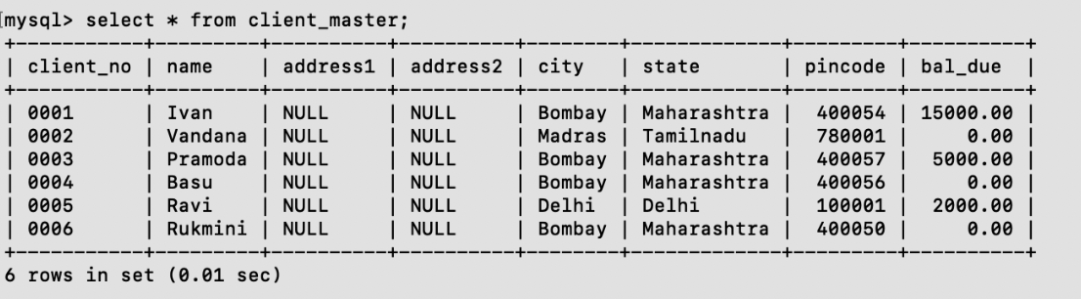

ii.

INSERT INTO Product_master

(Product_no, Description, Profit_percent, Unit_measure, Qty_on_hand, Reorder_lvl, Sell_price, Cost_price)

VALUES

('P00001', '1.44floppies', 5, 'piece', 100, 20, 525, 500),

('P03453', 'Monitors', 6, 'piece', 10, 3, 12000, 11200),

('P06734', 'Mouse', 5, 'piece', 20, 5, 1050, 500),

('P07865', '1.22 floppies', 5, 'piece', 100, 20, 525, 500),

('P07868', 'Keyboards', 2, 'piece', 10, 3, 3150, 3050),

('P07885', 'CD Drive', 2.5, 'piece', 10, 3, 5250, 5100),

('P07965', '540 HDD', 4, 'piece', 10, 3, 8400, 8000),

('P07975', '1.44 Drive', 5, 'piece', 10, 3, 1050, 1000),

('P08865', '1.22 Drive', 5, 'piece', 2, 3, 1050, 1000);

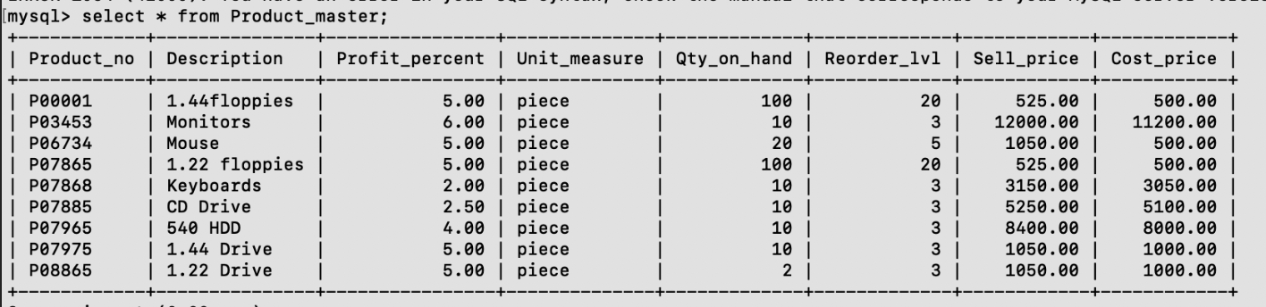

**Queries 3.**

1. select name from client_master;

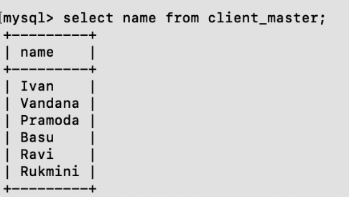

1. select name, city from client_master;

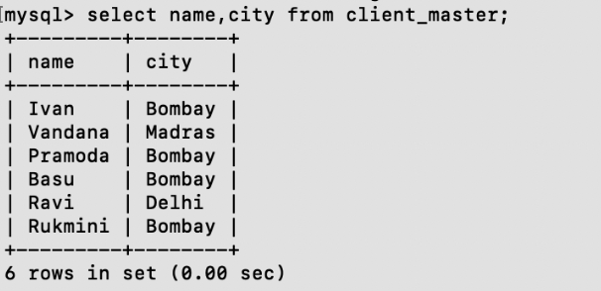

1. select Description from Product_master;

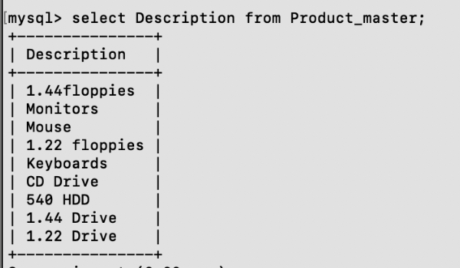

1. select name from client_master where city="Bombay";

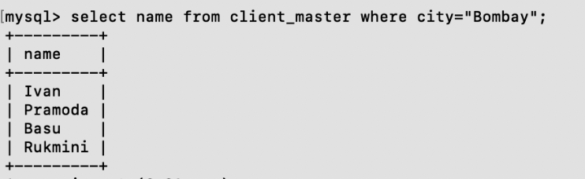

1. select * from client_ master where client_no = or or client_no = "0002";

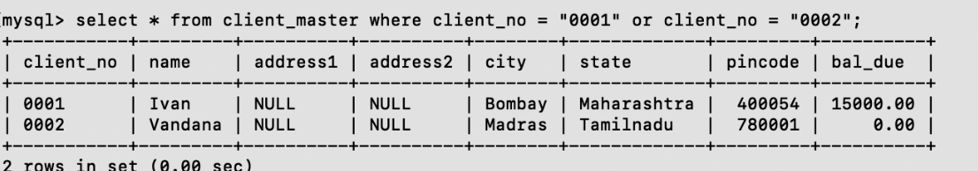

1. select * from Product_master where Description="1.44 drive" or Description="1.22 Drive";

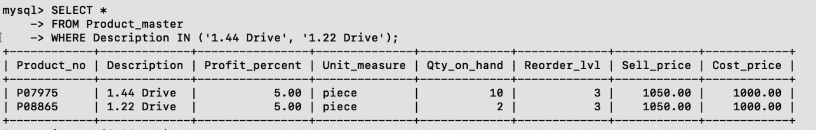

1. select * from Product_master where Sell_price> 5000;

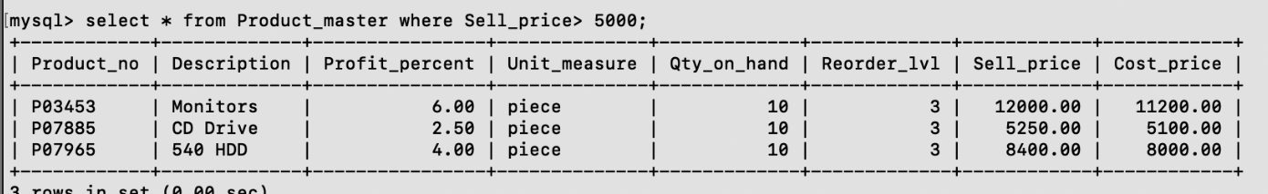

1. select * from client_master where city in( 'Bombay', 'Delhi', 'Madras');

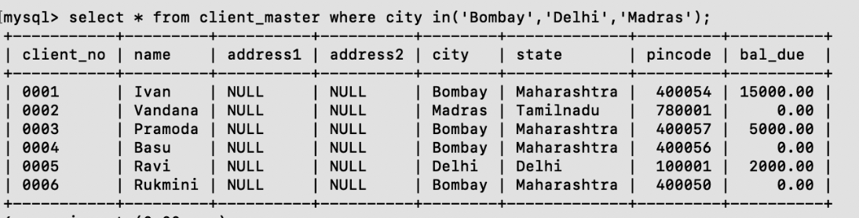

1. select * from Product_master where Sell_price> 2000 and Sell_price<= 5000;

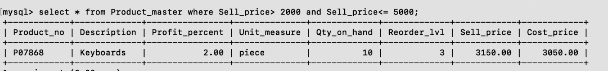

1. select * from client_master where state != "Maharashtra" ;

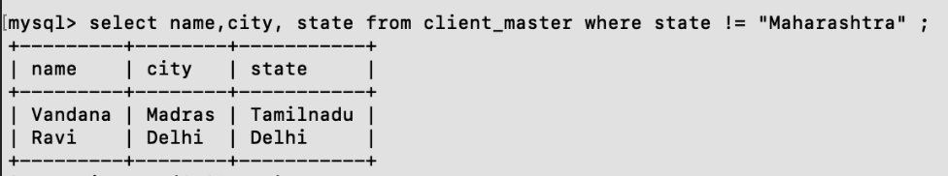

# Assignment No3

## Que.1 Using the table client master and product master answer the following queries.

1. Change the selling price of ‘1.44 floppy drive to Rs.1150.00
2. Delete the record with client 0001 from the client master table.
3. Change the city of client_no’0005’ to Bombay.
4. Change the bal_due of client_no ‘0001, to 1000.
5. Find the products whose selling price is more than 1500 and also find the new selling price as original selling price *15.
6. Find out the clients who stay in a city whose second letter is a.
7. Find out the name of all clients having ‘a’ as the second letter in their names.
8. List the products in sorted order of their description.
9. Count the total number of orders
10. Calculate the average price of all the products.
11. Calculate the minimum price of products.
12. Determine the maximum and minimum prices . Rename the tittle as ‘max_price’ and min_price respectively.
13. Count the number of products having price greater than or equal to 1500.

**Queries:**

1. update Product_master set Sell_price=1150.00 where Description = '1.44 drive';

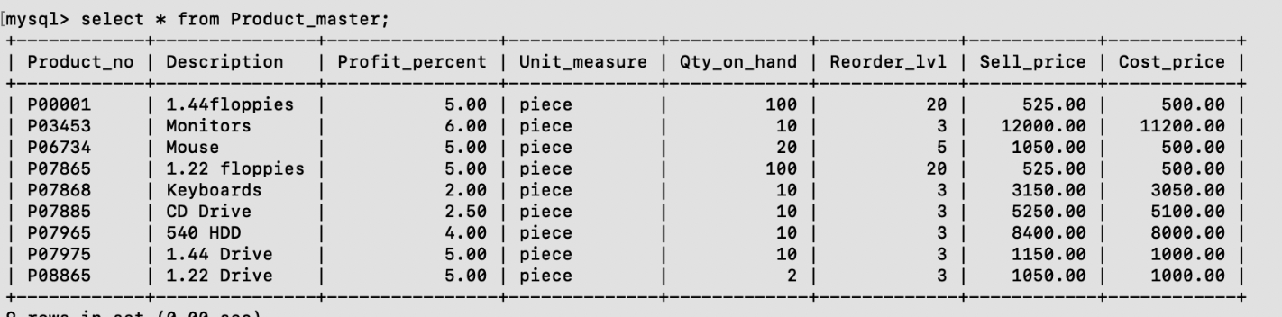

1. delete from client_master where client_no='0001';

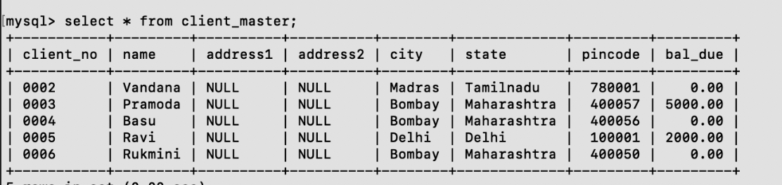

1. update client_master set city = 'Bombay' where client_no='0005';

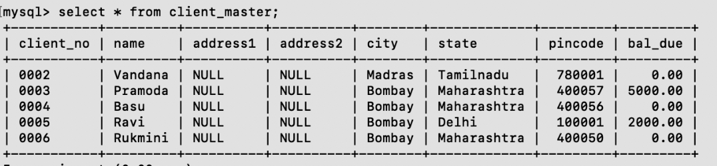

1. update client_master set bal_due = 1000 where client_no='0001';

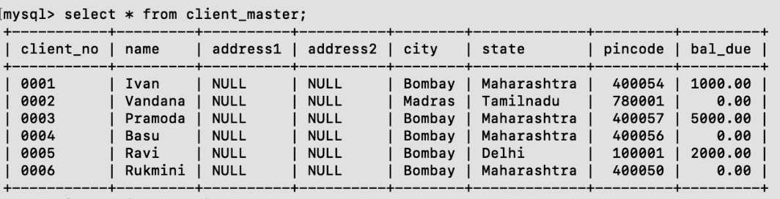

1. select Product_no, Description, Sell_price, (Sell_price*15) as New_selling_price from Product_master where Sell_price>1500;

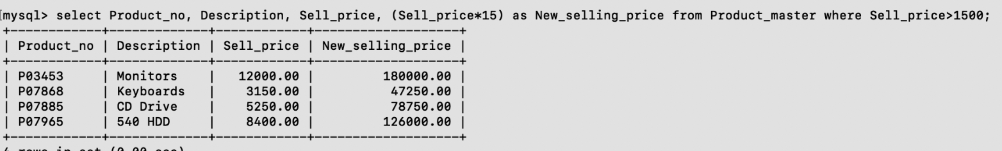

1. select * from client _master where city like "_a%" ;

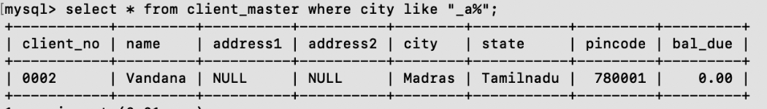

1. select name from client_master where name like "_a%" ;

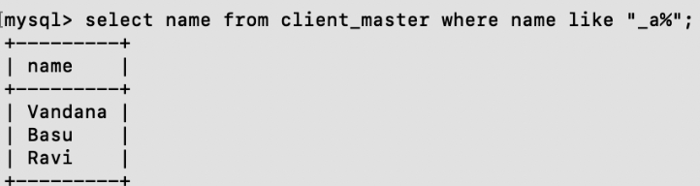

1. select * from Product_master order by Description;

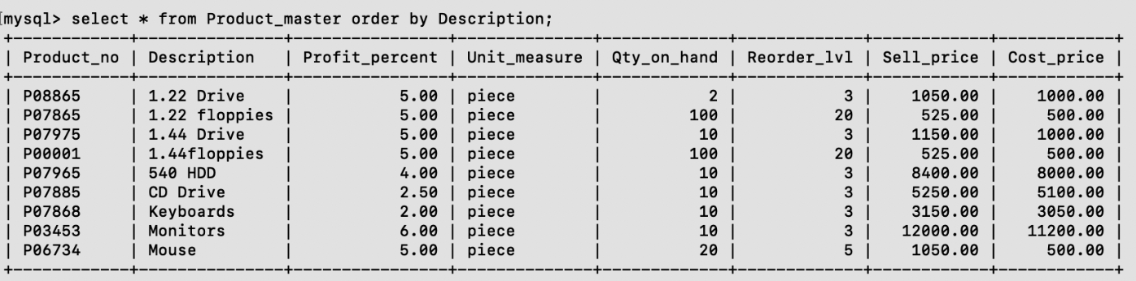

1. select sum(Qty_on_hand) as Total_number_of_orders from Product_master;

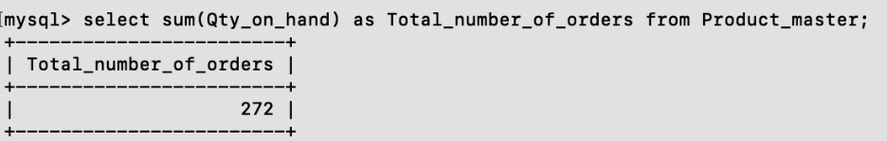

1. select avg(Cost_price) as Average_price from Product_master;

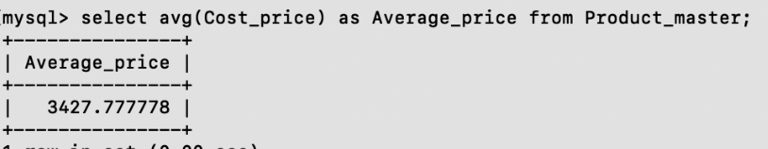

1. select min (Cost_price) as Minimum_price from Product_master;

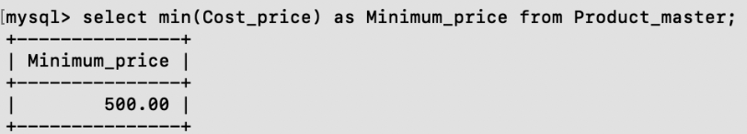

1. select max(Cost_price) as max_price, min (Cost_price) as min_price from Product_master;

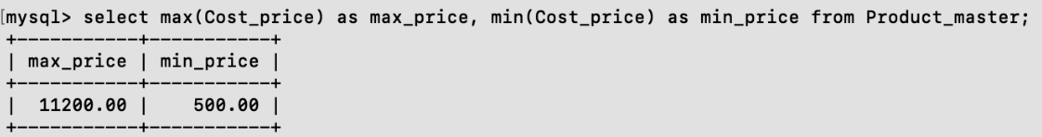

1. select count(*) as Product_count from Product_master where Sell_price>1500;

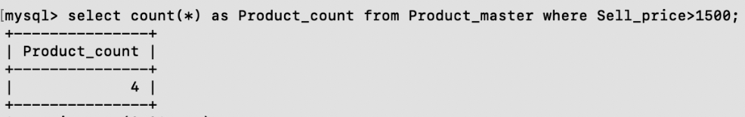

# Assignment No.4

**Question :**

* 1. Find average sell-price from product_master.
  2. Find minimum of balance due from client-master.
  3. Find the number of products from product-master.
  4. Find no of rows in table client_master.
  5. Find total balance due from client_master.
  6. Find absolute value of (-15).
  7. Find square of 3.

8 Find round (15.19,1).

1. Find square root of 25.
2. Find lower case of ‘MTECH”.
3. Find upper case of “gentleman”.
4. Write in proper case ‘MTECH”.

Queries:

1. select avg(Sell_price) as Average_price from Product_master;

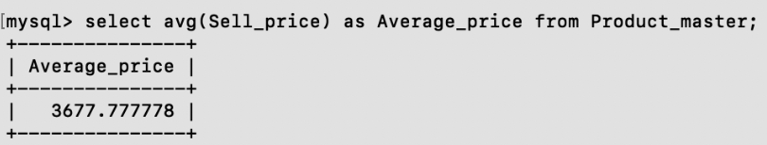

1. select min(bal_due) as min_bal_due from client_master;

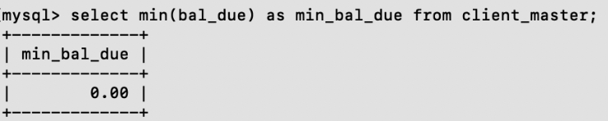

1. select count(*) as Total_products from Product_master;

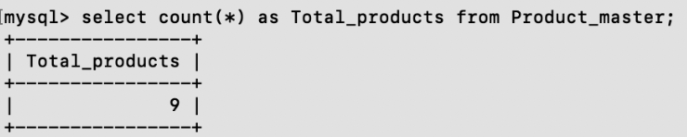

1. select count(*) as Total_rows from client_master;

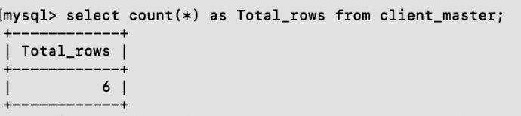

1. select sum (bal_due) as Total_bal_due from client_master;

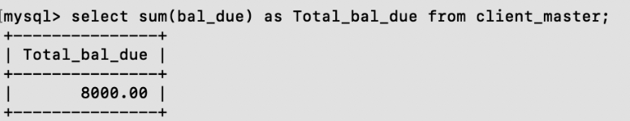

1. select abs(-15) as Absolute_value;

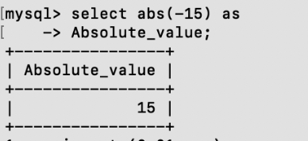

1. select 3*3 as Square_of_3;

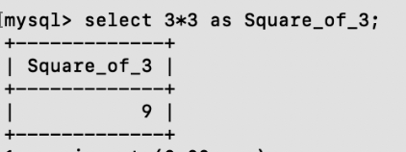

1. select round (15.19,1) as Rounded_value;

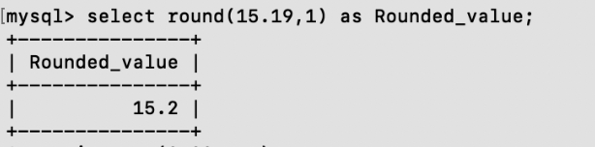

1. select sqrt(25) as Square_root_of_25;

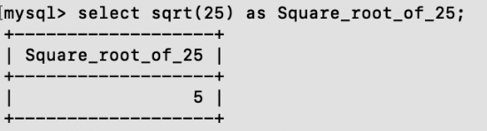

1. select lower ('MTECH') as Lower_case_MTECH;

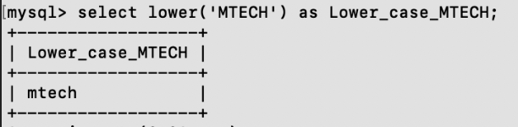

1. select upper( 'gentleman') as Upper_case_MTECH;

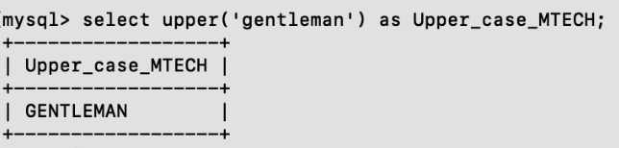

1. select concat( upper( left( 'MTECH', 1)), lower ( substring( 'MTECH', 2))) as Proper_case_MTECH;

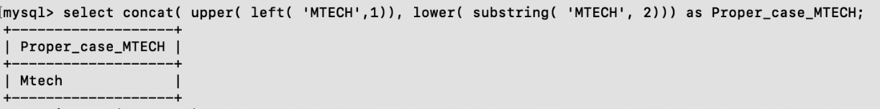

# Assignment No.5

**Question:**

1. Print the information from sales_order table for orders placed in the month of January.
2. Display the order_no & day on which clients placed their order.
3. Display the month and date when the order must be delivered.
4. Display the order date in the format DDMMYY.
5. Find the date i1 days after today’s date.
6. Find the no of days elapsed between today’s date and delivery date of the orders placed by the clients.
7. Print the description and total qty sold for each product in product_master.
8. Find the sum total of all the billed orders for the month of January.

Create sales_order Table:

create table sales_order Order_no int(6), Client_id int(5), Order_date date, Delivery_date date, Billed_amount decimal (10,2), Quantity_sold int (5));

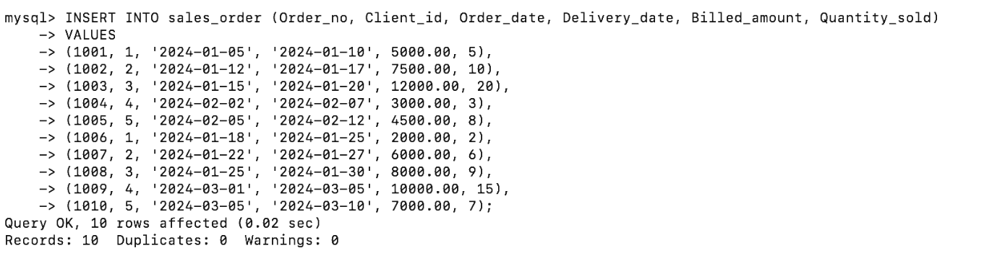

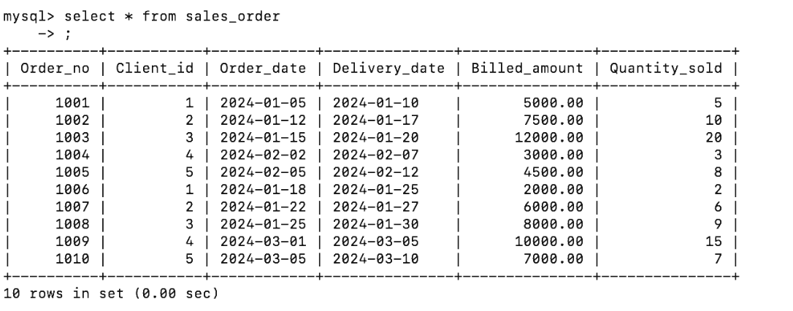

Queries:

1. select * from sales_order where month(Order_date)=1;

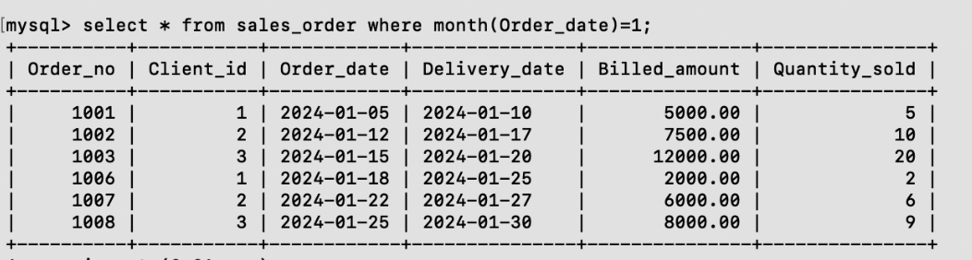

1. select Order_no, dayname (Order_date) as day from sales_order;

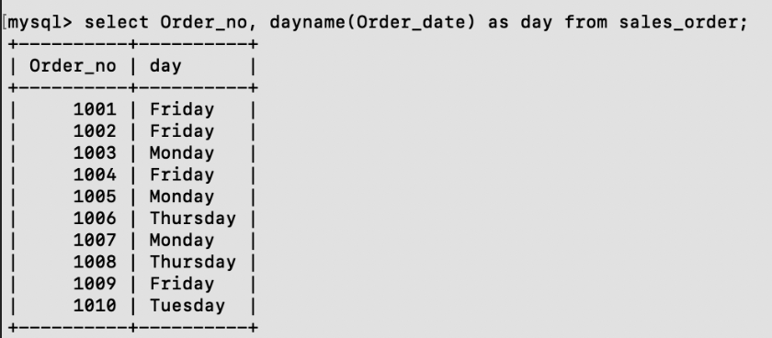

1. select Order_no, monthname (Delivery_date) as Month, dayname (Delivery_date) as Day from sales_order;

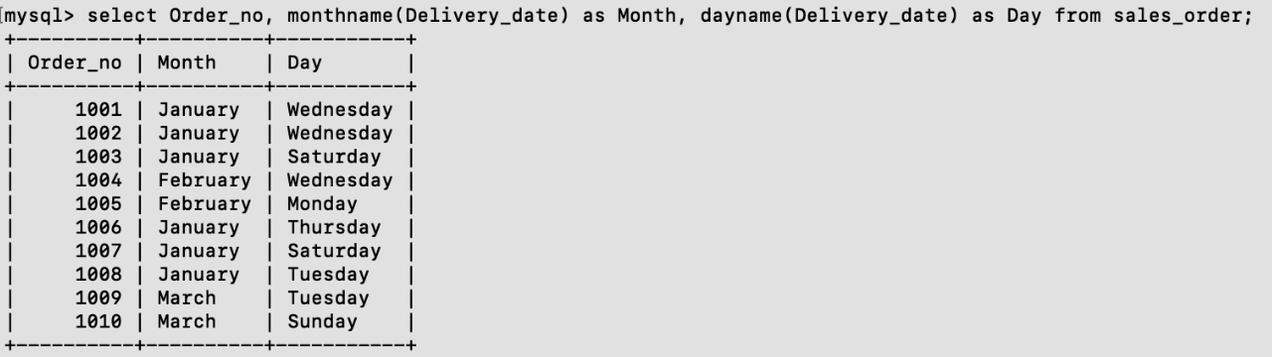

1. select Order_no, date_format (Order_date,'%d%m%') as Formated_order_date from sales_order;

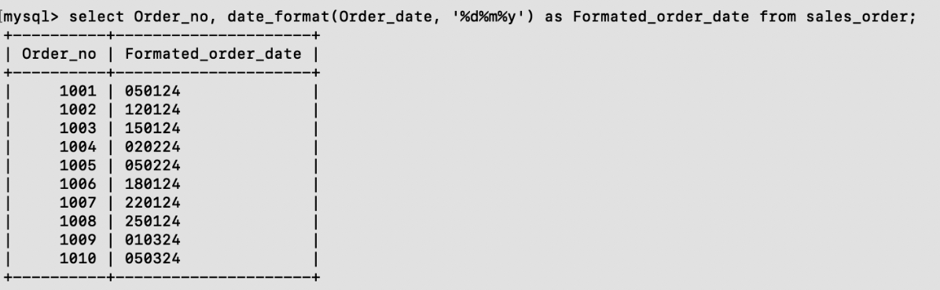

1. select curdate() as Today_date, date_add(curdate(), interval 11 day) as Date_of_11_days_after;

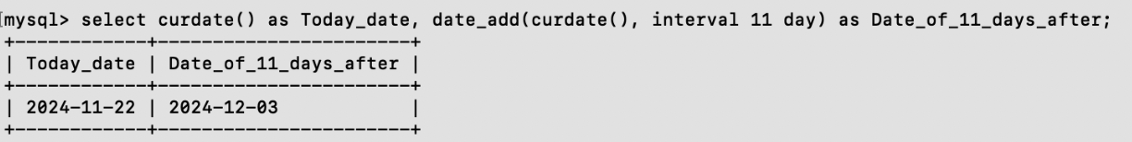

1. select Order_no, abs(datediff(Delivery_date, curdate())) as elapsed_days from sales_order;

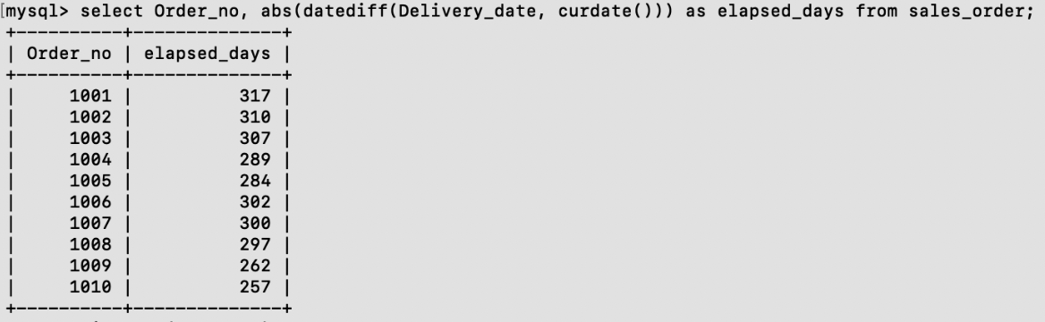

1. select Description, Qty_on_hand from Product_master;

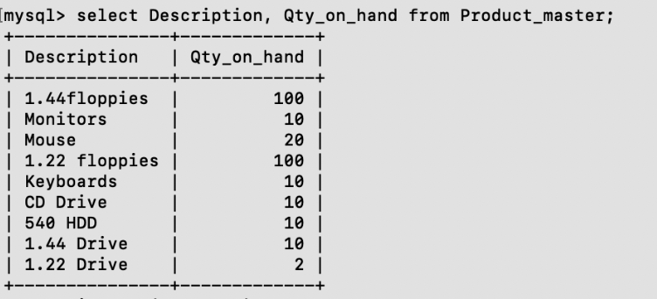

1. select sum (Billed_amount) from sales_order where month (Order_date)=1;

